Hybrid Infrastructure

🔀 What Is Hybrid Infrastructure?
# Source: AI Source: Provided by: [Data Path: Persons Table -> ID Column: 1, Name_En Column: Motasem Essam] -> From: [ChatGPT] on [1/26/2026]
Hybrid infrastructure is a combination of on-premises infrastructure and cloud infrastructure working together as a single integrated environment. It allows organizations to keep some resources locally while using the cloud for others.

🧠 Simple Definition:
# Source: AI Source: Provided by: [Data Path: Persons Table -> ID Column: 1, Name_En Column: Motasem Essam] -> From: [ChatGPT] on [1/26/2026]
Hybrid infrastructure means using both your own servers and cloud services together, depending on your needs.

🧰 Components of Hybrid Infrastructure
# Source: AI Source: Provided by: [Data Path: Persons Table -> ID Column: 1, Name_En Column: Motasem Essam] -> From: [ChatGPT] on [1/26/2026]
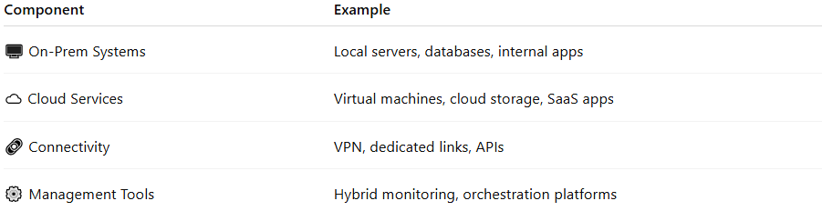
Component | Example
🖥️ On-Prem Systems | Local servers, databases, internal apps
☁️ Cloud Services | Virtual machines, cloud storage, SaaS apps
🔗 Connectivity | VPN, dedicated links, APIs
⚙️ Management Tools | Hybrid monitoring, orchestration platforms

🔒 Key Characteristics
# Source: AI Source: Provided by: [Data Path: Persons Table -> ID Column: 1, Name_En Column: Motasem Essam] -> From: [ChatGPT] on [1/26/2026]
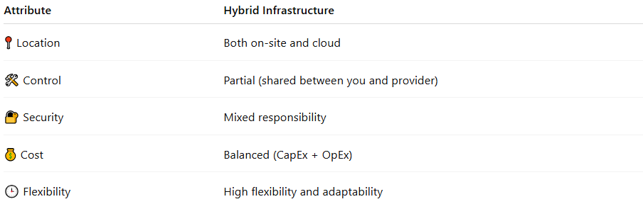
Attribute | Hybrid Infrastructure
📍 Location | Both on-site and cloud
🛠 Control | Partial (shared between you and provider)
🔐 Security | Mixed responsibility
💰 Cost | Balanced (CapEx + OpEx)
🕒 Flexibility | High flexibility and adaptability

📦 Benefits
# Source: AI Source: Provided by: [Data Path: Persons Table -> ID Column: 1, Name_En Column: Motasem Essam] -> From: [ChatGPT] on [1/26/2026]
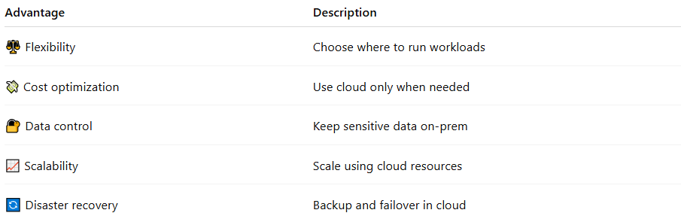
Advantage | Description
⚖️ Flexibility | Choose where to run workloads
💸 Cost optimization | Use cloud only when needed
🔐 Data control | Keep sensitive data on-prem
📈 Scalability | Scale using cloud resources
🔄 Disaster recovery | Backup and failover in cloud

⚠️ Challenges
# Source: AI Source: Provided by: [Data Path: Persons Table -> ID Column: 1, Name_En Column: Motasem Essam] -> From: [ChatGPT] on [1/26/2026]
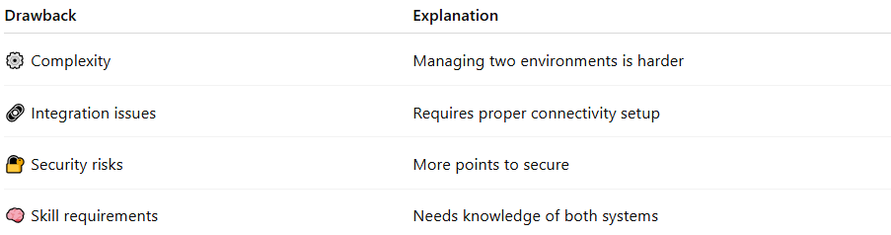
Drawback | Explanation
⚙️ Complexity | Managing two environments is harder
🔗 Integration issues | Requires proper connectivity setup
🔐 Security risks | More points to secure
🧠 Skill requirements | Needs knowledge of both systems

🆚 Quick Comparison
# Source: AI Source: Provided by: [Data Path: Persons Table -> ID Column: 1, Name_En Column: Motasem Essam] -> From: [ChatGPT] on [1/26/2026]
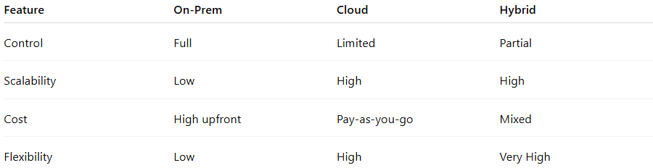
Feature | On-Prem | Cloud | Hybrid
Control | Full | Limited | Partial
Scalability | Low | High | High
Cost | High upfront | Pay-as-you-go | Mixed
Flexibility | Low | High | Very High

📌 Summary
# Source: AI Source: Provided by: [Data Path: Persons Table -> ID Column: 1, Name_En Column: Motasem Essam] -> From: [ChatGPT] on [1/26/2026]
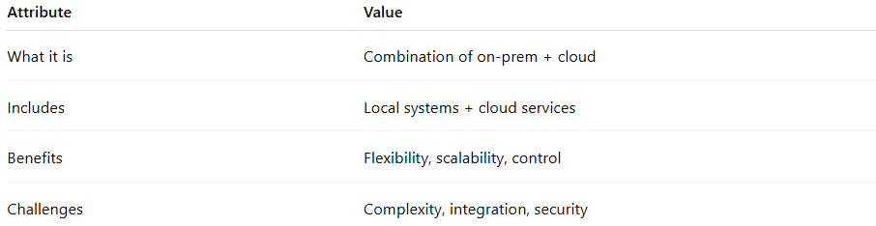
Attribute | Value
What it is | Combination of on-prem + cloud
Includes | Local systems + cloud services
Benefits | Flexibility, scalability, control
Challenges | Complexity, integration, security

